BFTO 50 Yard Bench Rest Competition Rules

The BFTO 50 Yard Bench Rest Competition Rules are as follows:

- This competition must only be shot on the Main Range and the target fixed to the designated metal target holder.
- The target holder can usually be found positioned in line with the range path and the 50yard range marker.
- The metal target holder is used as an aid for those witnessing the competition as each pellet strike on the target can clearly be heard and confirmed.
- All five shots must be witnessed, and the card signed and dated.
- The competition involves shooting five pellets at the target, attempting to achieve the tightest possible group.
- It does not matter where the group is relative to the target cross, but all five shots must be fully on the card to be valid. Please note that where there are less than five shots or more than five shots the card will be voided.
- The score awarded for a completed card will be the maximum measured spread of the pellet group.

Example:
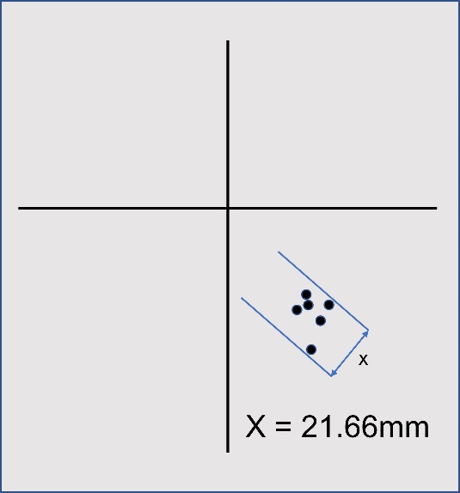

The aim for this competition is to achieve the lowest monthly score possible by shooting the tightest group.

Note:
- The best seven lowest scores count for the year.
- The competition winner will achieve the lowest combined seven scores.
- All competitors scores will be posted at the end of each month.
- If you wish to enter this competition, please leave a note in the score card box.

Regards BFTO.

